Heart of Ruin

Game Design Document
Version 1

Taliesin Games
Contents
1. Game Overview
1.1 Game Title
1.2 Development Team
1.3 Genre
1.4 Target Audience
1.5 Platform(s)
1.6 Elevator Pitch
1.7 Core Concept
1.8 Unique Selling Points

2. Core Gameplay
2.1 Gameplay Loop
2.2 Core Mechanics
2.3 Player Abilities
2.4 Progression

3. Story & World
3.1 Premise
3.2 Setting
3.3 Key Characters
3.4 Narrative Structure

4. Art & Visual Style
4.1 Art Direction
4.2 Character Design
4.3 Environment Design
4.4 UI/UX Style

5. Audio
5.1 Music Style
5.2 Sound Effects
5.3 Voice Acting

6. Technical Requirements
6.1 Engine
6.2 Tools & Pipelines
6.3 Performance Targets

7. Levels & Environments
7.1 Level List
7.2 Level Design Principles
7.3 Key Features/Challenges

8. Systems Design
8.1 Economy
8.2 AI Systems
8.3 Difficulty

9. UI/UX Design
9.1 Menus
9.2 HUD
9.3 Accessibility Features

10. Monetisation
10.1 Model
10.2 In-Game Purchases

11. Project Scope
11.1 Team Roles
11.2 Timeline
11.3 Budget (Optional) (Optional)

This document is subject to change throughout the development of this game.

1. Game Overview
1.1 Game Title
Heart of Ruin

1.2 Development Team
Taliesin Games was founded in September 2025 by a group of University of Derby students on the Computer Games programmes. The project was started as part of the Game Development team module and is expected to continue once the degree element has been completed.

Art
Steven Holmes
Claire Peacey
Daniel Sullivan
Daniel Clamp
Programming
David Mulgrew
Callum Streets

Damian Turner

1.3 Genre
Multiplayer Action Roguelite

1.4 Target Audience
Young Adult (20 – 34).
Indie Curious.

1.5 Platform(s)
Primary: PC
Target Platforms: Steam Machine, PlayStation 5, Xbox Series X/S, Nintendo Switch 2.

1.6 Elevator Pitch
Heart of Ruin is a fast-paced multiplayer action-roguelite where players battle through corrupted biomes to recover the lost pages of a shattered spellbook and complete the incantation left unfinished by a fallen wizard. Each recovered page unlocks new options, while a dynamic tension meter heightens risk. Fight the boss on your terms, but push too far, and the biome boss will break free, blending skill-based combat, exploration, and suspense unlike any other game.

1.7 Core Concept
Players take on the role of a member of the guild, continuing the mission of the Wizard, whose life was sacrificed to stop the Heart of Ruin. The wizard’s spell failed, scattering the pages of his tome across corrupted lands. Each recovered page unlocks new abilities and progression options.

1.8 Unique Selling Points
- Dynamic Tension System: The tension meter responds to collective player actions; high tension triggers boss engagement, forcing teams to manage risk and strategy together.
- Integrated Narrative & Mechanics: Progression directly impacts story and spell completion.
- Cooperative Spellbook Reconstruction: Players work together to collect scattered pages, unlocking unique group-based spells, abilities, and combos.
- Corrupted Biomes as Active Threats: Each biome reacts dynamically to player actions, with environmental hazards and AI-controlled monsters scaling with party size.
- Skill Forward Cooperative Combat: Combat rewards both player skill and progression. Players can coordinate dodges, spells, and attack combos, while upgrading stats and abilities to increase their effectiveness. A variable skill ceiling allows beginners to contribute meaningfully, whilst giving experienced players opportunities to master advanced combos, strategy, and timing.
- Safe Haven Multiplayer Hub: Shared safe point where players can trade, craft, fast travel between biomes, form parties, and engage with narrative elements. A central space for planning, social interaction, and preparation between runs.

2. Core Gameplay
2.1 Gameplay Loop
Run > Kill Boss > Recover Pages > Return to Safe Haven > Upgrade > Repeat.

2.2 Core Mechanics
Each run challenges players to balance aggression and caution as the tension gauge rises, pushing the risk–reward dynamic. Progress persists across runs through spellbook reconstruction, character growth, and equipment, encouraging mastery and experimentation.
- Tension System: Actions increase biome tension. Reach maximum tension and the boss breaks free, forcing an immediate encounter.
- Cooperative Multiplayer (1–4 players): Players coordinate attacks, revives, utility, and synergy-based ability combos.
- Roguelite Progression: Persistent advancement through unlockable abilities, stats, heroes, and spellbook upgrades.
- Spellbook Reconstruction: Recover pages to complete the unfinished incantation left by the Wizard, unlocking new mechanics and long-term meta progression.
- Safe Haven Hub: Shared multiplayer camp for trading, crafting, upgrades, fast travel, and narrative delivery.

2.3 Player Abilities
- Basic Movement: Move, dodge, and reposition quickly in and out of combat.
- Melee Combat: Perform close-range attacks using melee weapons of varying speed and power (1H/2H Weapons)
- Ranged Combat: Engage enemies from a safe distance.
- Magical Combat: Wield magical weapons or abilities, allowing variation of magical attacks that compliment melee and ranged attacks.
- Co-op Interactions: Assist each other, revive allies, and create combination spell synergies.
- Environmental Interaction: Activate key objects, cleanse corruption at points of interest, or collect spell fragments.

2.4 Progression
- Run-based progression: Players grow stronger during each successful run by collecting weapons, magical abilities, and artifacts.
- Spellbook Pages: Recovering lost pages unlocks new abilities and permanent stat upgrades for future runs.
- Character Growth: Players can enhance stats like health, mana, strength, dexterity, and intelligence.
- Team Synergy: Some upgrades improve cooperative effects, encouraging multiplayer gameplay.
- Meta-progression: Over multiple runs, players can unlock new classes, abilities and passives that persist between sessions.

3. Story & World
3.1 Premise
The veil of reality has been torn apart. From the rift came a god of malice, unleashing a singularity. The vortex of corruption siphons lifeforce and magic, leaving only ruin.
In desperation a lone wizard stood against this darkness, hoping to bind the corruption. But the spell failed. His body was torn asunder, his tome shattered, its pages scattered across the world.
Now, the Heart of Ruin pulses at the centre of creation’s decay. You must venture into its ever-changing depths, battling corruption to recover the lost pages of the wizard’s tome.
Seek refuge in the divine-sanctified haven, where you rest, plan, and prepare. Beyond its walls lie shifting domains, teeming with monsters, traps, and forgotten magic. Every descent is perilous, every page vital. The fate of the world hangs in the balance.

3.2 Setting
Heart of Ruin takes place in a fantastical world torn apart by the rift of corruption. The environment is dynamic and ever changing, with biomes that shift and mutate, reflecting the spread of God of Malice’s influence.
Players will explore corrupted forests, desolate wastelands, and arcane infused landscapes, each teeming with monsters, traps and hidden magic. At the centre of it all lies the Heart of Ruin, a pulsating core of decay that drives the corruption throughout. Safe Havens serve as respites where players can rest, plan, and prepare before venturing into the perilous unknowns ahead.

3.3 Key Characters
The Lone Wizard – NPC.
A legendary figure and founder of the guild, devoted to maintaining balance between life and magical forces. Though he no longer exists in physical form, his presence is felt through the scattered pages of his shattered tome. These relics contain fragments of a spell powerful enough to contain the Heart of Ruin. The Wizards’ teachings, strategies and vision continue to guide the player, who as his successor carries the responsibility to rebuild the tome, speak the incantation, and confront the corruption.
Born in an era of fragile balance between nature and magic, the Wizard displayed great talent from a young age. He founded the guild to protect knowledge and life, training disciples in the responsible use of magic. When the god of malice unleashed the singularity, he attempted a spell to contain it, but the ritual failed, destroying the wizard entirely.
His sacrifice and teachings define the standard for all successors, and every recovered page brings the world one step closer to its salvation.

The Elf – Player Character.
A young, female elf from the mystical Verdant Glade, a secluded forest rich with magical flora and ancient trees. Slim, graceful and agile, she embodies the typical elven physique, adorned in lightweight, flexible armour and natural accessories that reflect her connection to nature. Her bright, expressive eyes and flowing hair convey both curiosity and affinity with the living world.
Trained and mentored by the Wizard, she learned a fragment of his magic that harmonises with life, alongside survival, combat and exploration skills. When the Heart of Ruin shattered the world, corrupting the lands and twisting creatures into monsters, she set out to recover the scattered pages of the Wizards spellbook. Driven by empathy, curiosity, and a sense of duty, she ventures into corrupted zones, battling the spreading darkness and striving to restore balance.
Her skill with weapons, agility, and magical abilities makes her a formidable force through a world where nature itself has turned against her.

The Human – Player Character.
A middle-aged warrior born into a family with a long tradition of service to the crown. Muscular and battle hardened, he wears practical armour and carries a weapon of choice, marked with the scars and experience of decades of combat. Calm, disciplined, and tactical, he prioritises action over words and acts according to a strict code of honour.
Raised with the Royal Guard, he trained in combat, strategy, and loyalty from childhood. His path crossed with the guild through missions that aligned with his duty to protect the kingdom. When the Heart of Ruin spread corruption, he partnered with guild members to confront the threat, applying his experience, discipline, and unwavering resolve. Though independent in method, he shares the guilds goals, protecting the innocent and facing corruption head-on while embodying the principles of courage, duty and steadfastness.

3.4 Narrative Structure
Heart of Ruin uses a run-based narrative where the overarching story unfolds through exploration and recovery of the Wizards tome pages. The narrative structure combines persistent story with run events.
- Story Progression
  - The worlds state changes as players recover pages, gradually revealing more of the history and background.
  - Successive runs unlock new abilities, areas, and lore, connecting the player’s actions to long term world restoration.
- Run-Based Narrative
  - Each descent into the Heart of Ruin is a self-contained story segment, presenting unique challenges, events, and encounters.
  - Players interact with corrupted creatures, environmental hazards, and hidden secrets whilst recovering spell pages.
  - Optional narrative events may reveal character backstory, guild lore, or fragments of magical knowledge.
- Character Development
  - Character growth through gameplay, reflecting their increasing mastery, understanding of the corruption, and their relationship to the Wizard.
  - Player choices during exploration, combat, and interaction influence character development and unlock optional narrative content.
- Endgame
  - As the tome is reconstructed, players gain the knowledge and power to confront the God of Malice directly.
  - The final confrontation is a combination of strategic combat, learned abilities, and narrative resolution culminating in the restoration of balance throughout the world.

4. Art & Visual Style
4.1 Art Direction
Overall Aesthetic
The games overall aesthetic blends illustrative stylised fantasy art with dynamic high-clarity action readability. The visual identity pulls Dofus’ whimsical charm, while incorporating the bold, energetic presentation of games like Hades. Environments, characters, and effects are designed with a hand-painted, slightly exaggerated look, prioritising shape language and colour harmony.
The world feels vibrant, magical and alive. Organic shapes and flowing silhouettes create a sense of natural beauty within the Wildwood Biome. Magical corruption, glowing flora and other bioluminescence break up the natural palette, reinforcing the theme of a forest saturated with corruption and arcane energy.
Influences and References
Heart of Ruin is influenced by several key titles.
Dofus - established baseline art style for environments.
- Clean and simple art style.
- Exaggerated but charming.
- Warm, painted colour palettes.
Hades – ensures the games combat remains visually exciting and readable.
- High contrast.
- Strong, iconic silhouettes.
- Vibrant, reactive VFX.
- Dynamic.
Curse of the Dead Gods – strengthens magical corruption theme whilst maintaining a painted aesthetic.
- Heavy directional lighting to carve silhouettes.
- Stylised shadows to shape room mood.
- Torchlight, magical flames, and colour driven illumination.
Ori and the Blind Forest – defines the magical essence of the Wildwood biome.
- Bioluminescent flora.
- Layered backgrounds with soft glows.
- Mystical light beams and atmospheric fog.
- Uses colour to convey environmental emotion.
Traditional Folklore Art & Illustrations – adds real world historical elements to a stylised fantastical world.
- Knotted roots, winding branches.
- Forest spirits and mystical fauna.
- Organic motifs.
- Mystical and folklore creatures.
Lighting Style: TBC – This is a suggestion!
Heart of Ruin blends stylised soft illumination, dynamic contrast, and directional mood lighting. The result is a whimsical yet treacherous atmosphere that reinforces the mystical dangers of the Wildwood.
During combat, lighting shift to high contrast, rim-lit silhouettes, highlighting the player and enemies using bright accentuated colours for visualisation. This ensures fast action remains clear without losing the painted style.
The Heart of Ruin itself is a purple black “black hole” shader that spreads a low opacity fog over nearby terrain. Its pulsing glow tints the environment, adding subtle lighting to nearby objects and creatures, signalling corruption and danger. Despite this overlay, silhouettes and gameplay elements remain highly readable through controlled fog intensity, opacity and contrast.
Tone & Atmosphere:
The wildwood biome embodies a dual nature; vibrant and alive on the surface yet haunted by deep-rooted magic that corrupts it to its core. This balance between charm and menace defines the overall emotional experience.
The forest itself feels alive and reactive. Magic, glowing spores, and bioluminescent flora light the environment. Despite its beauty, the Wildwood carries a constant sense of unease. Twisted roots obscure paths, corruption hums with unstable energy, and the light behaves strangely.
The atmosphere aims to establish a world where magic is beautiful but volatile, and every part of the forest, flora and fauna contributes to a sense of wonder and danger simultaneously.

Colour Palette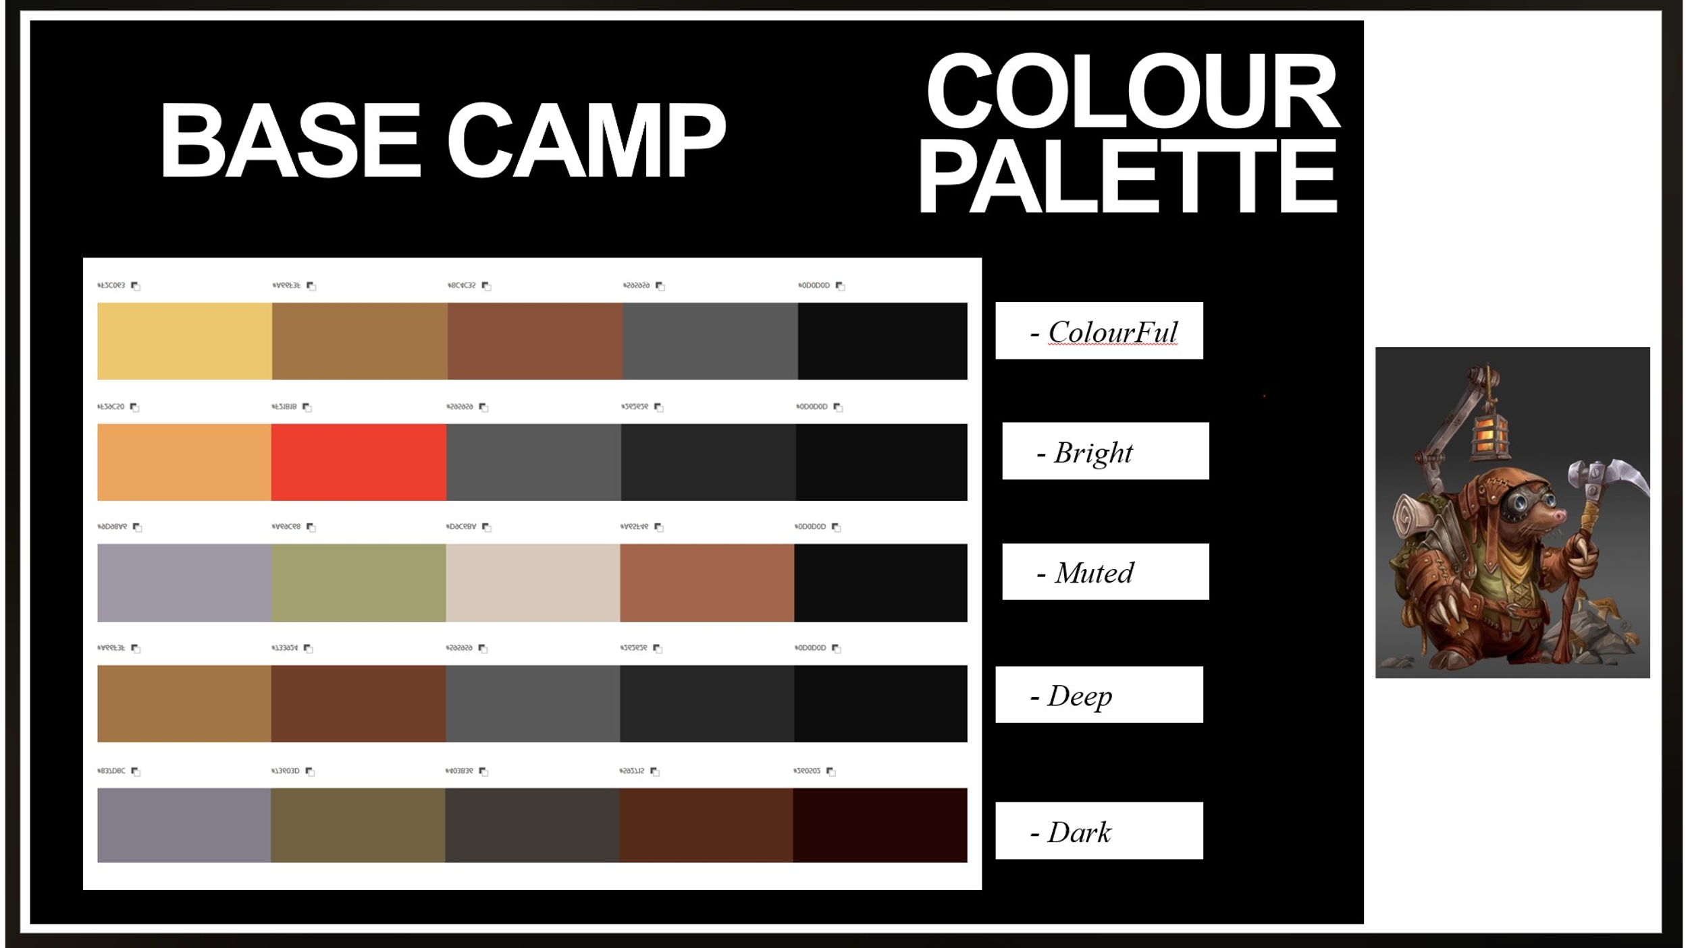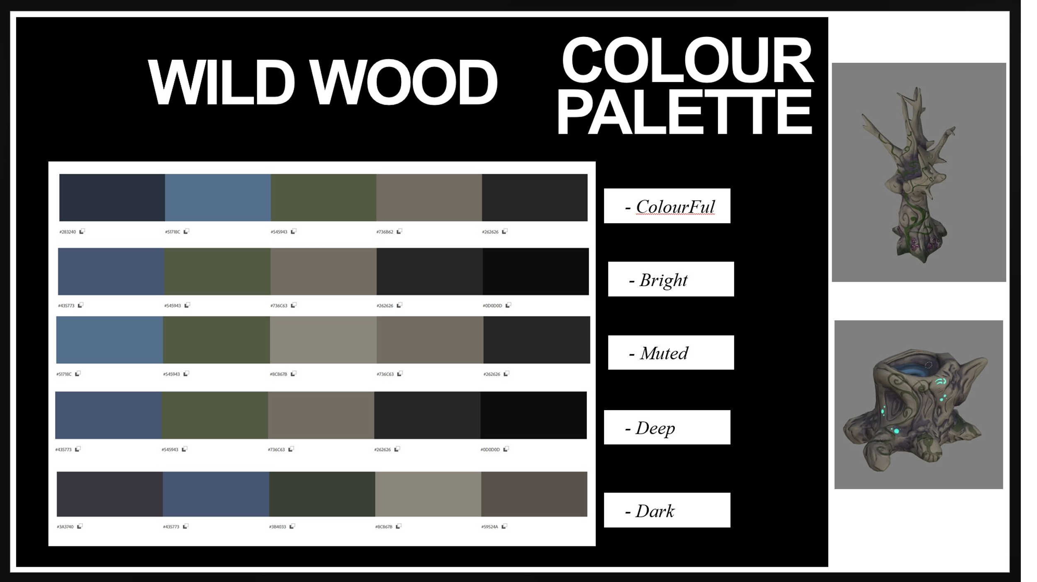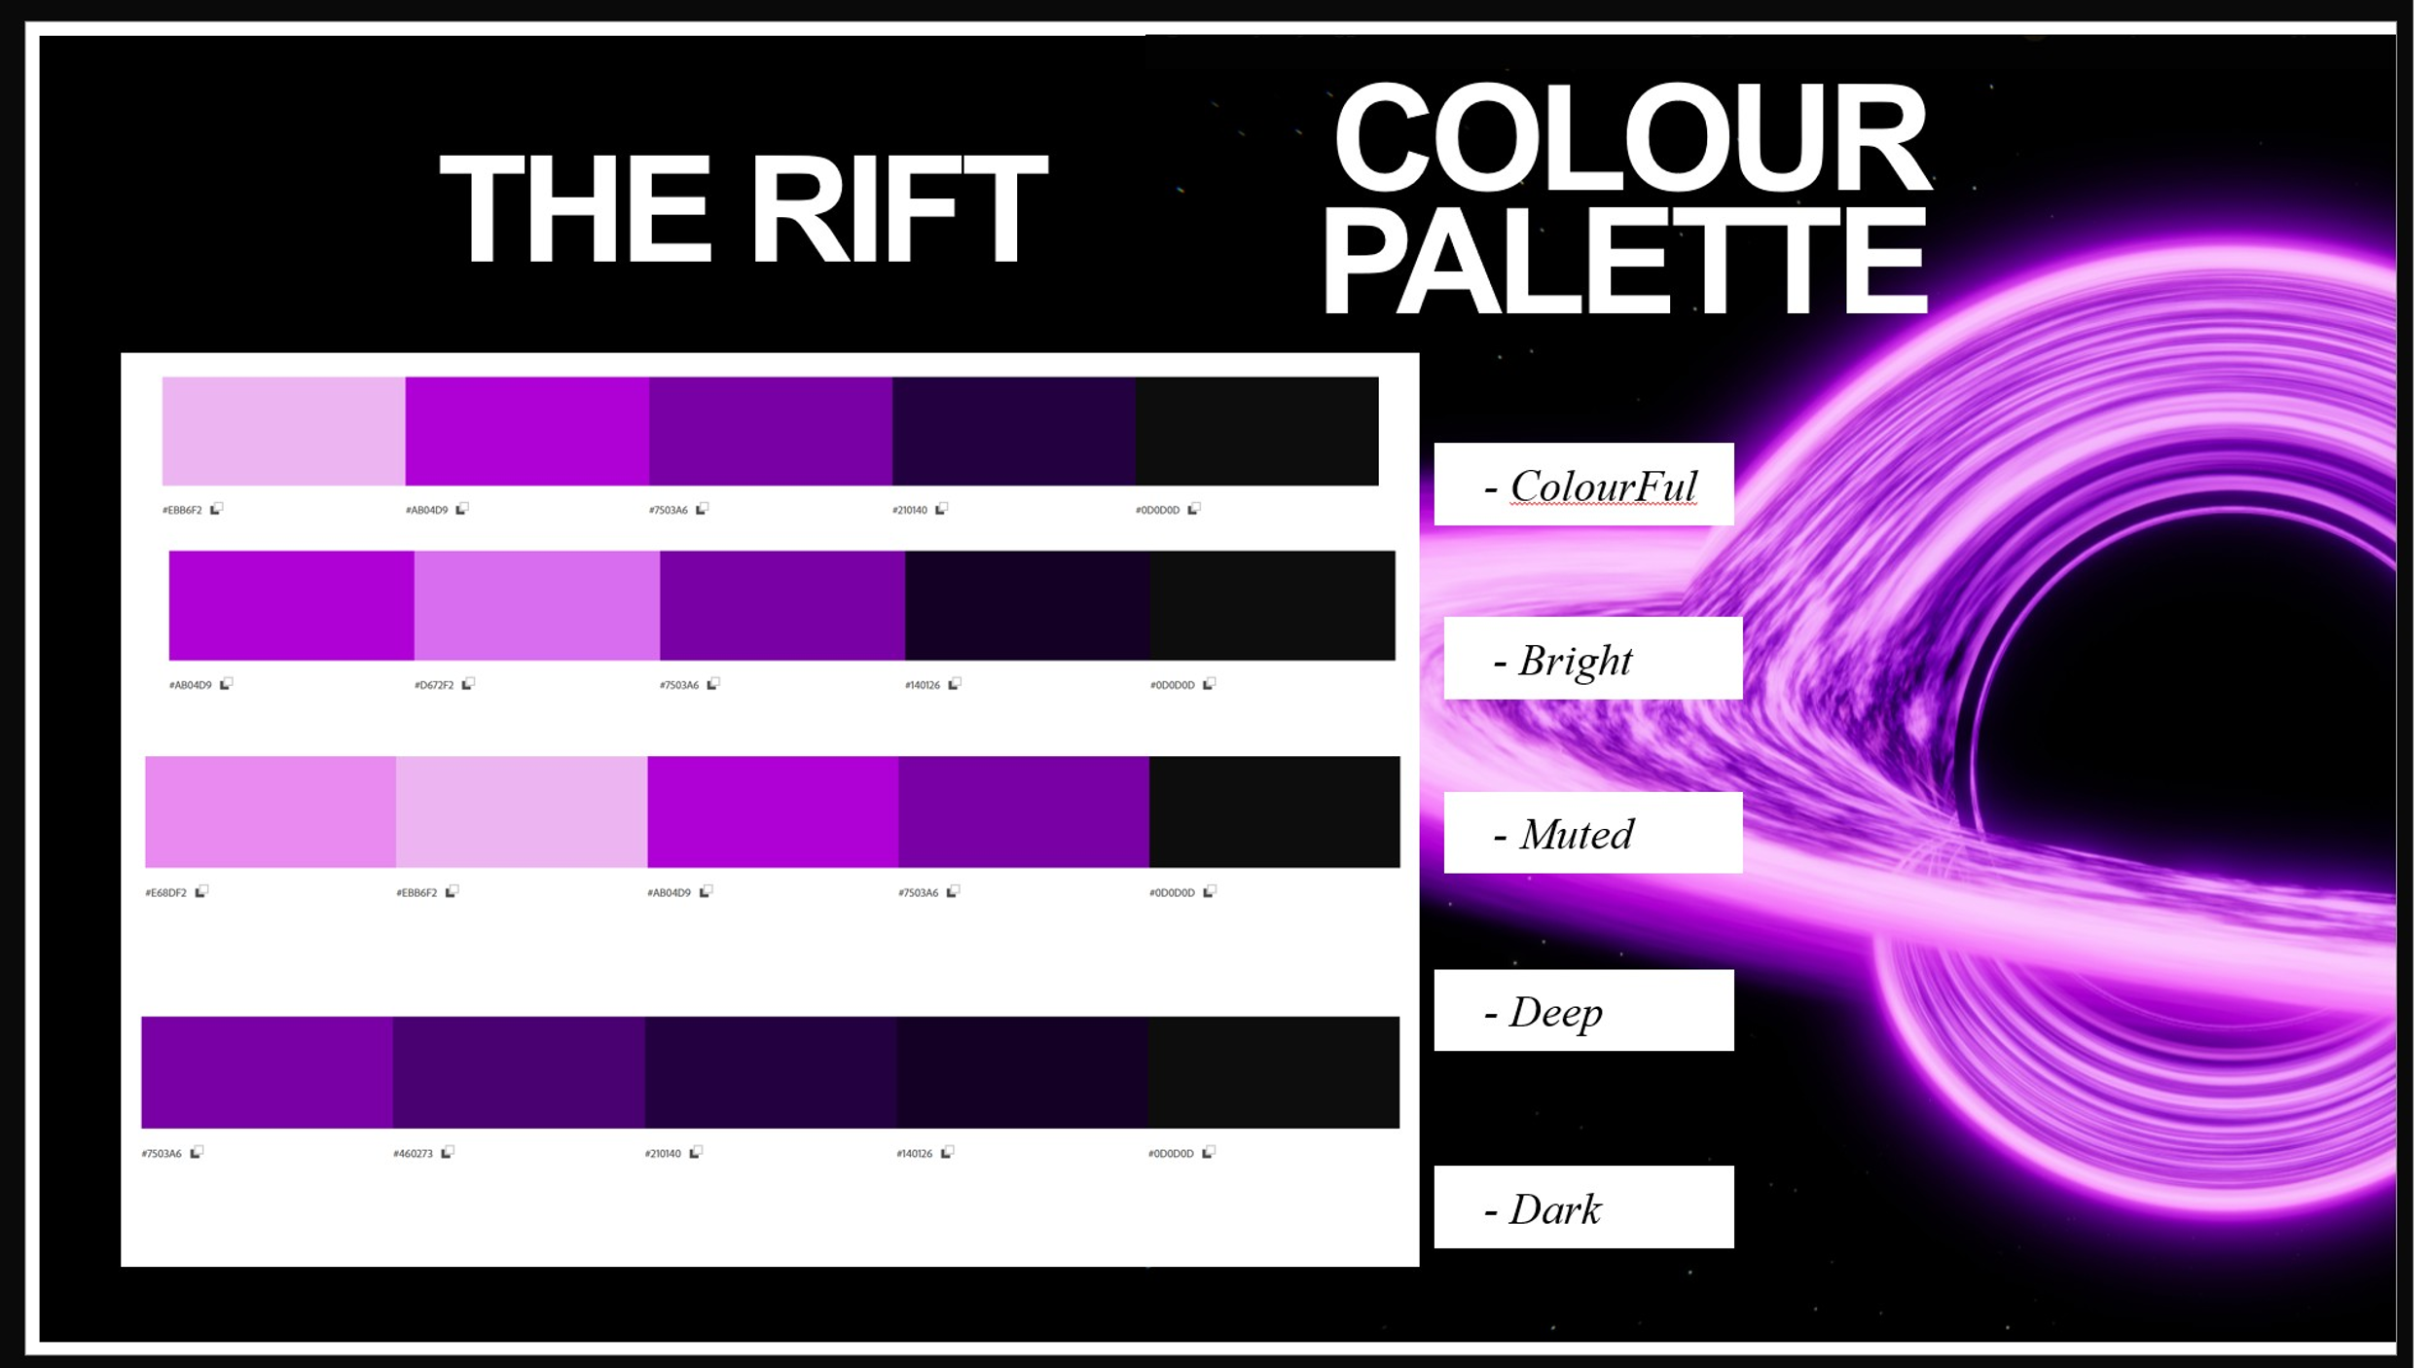
4.2 Character Design
Character design balances charm, readability and visual storytelling. Silhouette clarity, contrasting colours and expressive details are critical to make each character instantly recognisable.

4.3 Environment Design
4.4 UI/UX Style

5. Audio
5.1 Music Style
5.2 Sound Effects
5.3 Voice Acting

6. Technical Requirements
6.1 Engine
6.2 Tools & Pipelines
6.3 Performance Targets

7. Levels & Environments
7.1 Level List
7.2 Level Design Principles
7.3 Key Features/Challenges

8. Systems Design
8.1 Economy
8.2 AI Systems
8.3 Difficulty

9. UI/UX Design
9.1 Menus
9.2 HUD
9.3 Accessibility Features

10. Monetisation
10.1 Model
10.2 In-Game Purchases

11. Project Scope
11.1 Team Roles
11.2 Timeline
11.3 Budget

